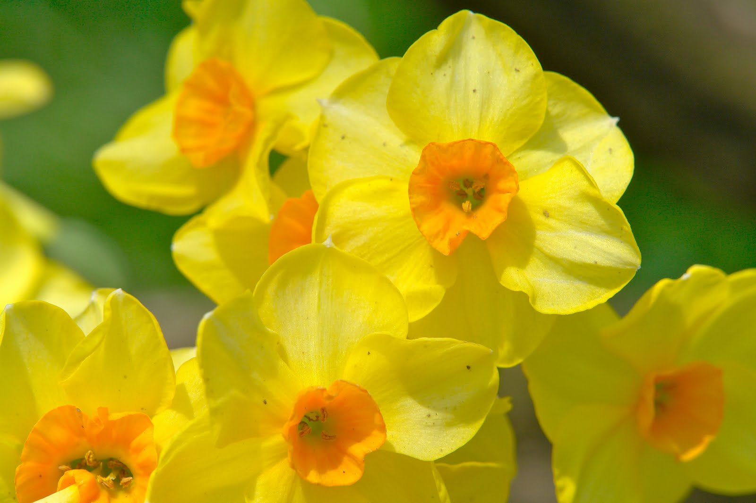
Hello!!
Aqsa, Jake, Malena, Robert, Noah, Steven and Anders.
It was lovely to get to talk to some of you before Easter and hear how busy you have been and see your work.
I hope you had a nice Easter and enjoyed some Easter eggs!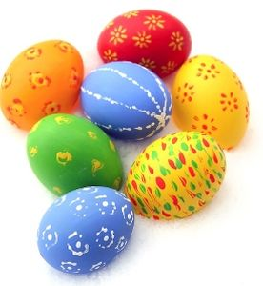
I feel very sad that we can’t be back in school but we must stay at home for another while.
I have attached some work for you to do and you can contact me on my email if you would like to talk to me.
If you have your books you may continue with those. Here is a plan of work for the week.
If you need to contact me you have my email and phone number.
Mum and Dad, again, this is only a guide. Do what you can manage.
Please contact me if you need anything. There is an activities pack with some extra ideas if you need them or if you don’t have the books.
Oral Language: Our theme is still all things Spring.
We had been learning the names of animals and their babies. There is a sheet in the activities pack on this.
Go out into your garden if you have one and learn the names of the flowers growing there.
Learn the parts of a flower with mum and dad.
Use small world page 61 (its in the activities pack also) to help you. Write the names of your flowers in your bumble bee copy or in any copy or on some paper if you don’t have your books.
Draw and label the parts of a flower in your copy. Help Mum and Dad in the garden. Find out what a weed is.

I’ve included some funny tongue twisters for you to try at home.
You will find them in the activities pack. Get Mum and Dad to try them too.
Phonics: If you are doing ‘Sounds like Phonics B’
Google “cjfallon quicklinks”
• Click sounds like phonics
• Click Activity book B
• Click “unit 1 The Park”.
Revise the consonnent diagraphs: sh, ch, th, wh, ph,
Do one a day. Play all the games that go with the sound.

If you are doing ‘Sounds like phonics C’ (AB)
Google “cjfallon quicklinks”
- Click Primary
• Click sounds like phonics
• Click Activity book C
• Click “unit 1 The Aquarium”.
Revise the final sounds shown. Play the games that go with each sound. Do one or two sounds per day.

Reading:
If you want to practice your reading you can go to:
Google “cjfallon quicklinks”
- Click my.cjfallon.ie at the bottom of that page.
• Click: Primary, Junior infants, English,
• under series click Rainbow- Stage 1
• Click Core Reader 1 –New Friends
There are three stories Read one story per day.
Then draw a picture and write a sentence about the story. (in your English copy if you have it- the one with the pencils on the front)

If you are working on the Two Little Frogs Book (AB)
Then you need to go to Google “cjfallon quicklinks”
- Click my.cjfallon.ie at the bottom of that page.
• Click: Primary, First Class, English,
• under series click Rainbow- Stage 1
• Click Core Reader 1 – At the Beach.
There are three stories Read one story per day and continue with The Three Little Frogs reading and activities.
If you are working on the Green Book ‘working on high frequency words Book 1’ (JCW & MJ )
Go on to the next list. Mum or Dad could write the words 3/4 times on an old cereal box so you can practice saying them quickly.
Do one page from the Green workbook per day.
Writing:
Continue to keep a diary of what you are doing each week.
Continue with your writing book if you have your book.
See the activity folder for writing sheets if you need more to do.
There are some great word searches there too.

Maths:
Senior Infants:
Busy at Maths P 62 and P 63
Also try www.topmarks.co.uk
Go into 5-7 year old
Choose measures in category
Play the- Lets Compare Game.

Maths:
First Class:
Busy at Maths p49-55
Also try www.topmarks.co.uk
Go into 5-7 year old
Under Category choose measures
Play the coconuts game and the measuring in cm game.
SESE: Small World Book
P34 learning about different Materials-search your home for these materials.
P35 Healthy Habits- see how many of these healthy habits you have.
The pages are in the activities folder attached if you don’t have your books.
Or go to
- cjfallon quick links
- Click Primary
- Senior infants
- SESE
- Small world and go to the page number.
Print the page if you can.
Art: Learn to draw a car, a clown, a T-rex or a flower.
If you look up ‘learn to draw a…’ on the computer with Mum or Dad you will find instructions on how to do this.
Or if you want to learn to draw something else that’s fine. I’ve included some ‘ how to draw’ activities in the activities folder also.
If you would like to email me your picture I would love to see it.
Mum or Dad could take a photo of it and email it to me.
P.E.
Go noodle and Joe wicks- All have great workouts for you to try online.
Cosmic Kids have simple yoga poses to try.
Playing outside is the best exercise. Play on the trampoline, ride your bike, walk your dog, make a castle.
SPHE: Before the holidays we were learning about Friendship:
Have a look at this power-point with mum and dad. Draw a picture of your friends and write their names.
You could learn to tie your shoes. Make your own bed.
Help Mum and Dad tidy the house. Help in the garden.
Hang out the clothes. Fold clothes. Match socks etc.

