Dear parents,
I hope you are all keeping well. Here is the next fortnights work. As always, please email me if you have any questions or if ye would like to show me any work that ye have completed.
As I mentioned last week, I have some children completing English activities on www.studyladder.com . If you would like me to assign work for your child, let me know and I will set them up.
This week we are going to try out a new online maths programme. I have attached log in details. Please change initial password after registering your account. If you are finding the programme too easy or too challenging email me and I can adjust accordingly.
Lastly, if anyone needs to collect books from school it will be possible from May 18th but strictly by appointment only. Please contact Ber on ber@greenmount.ie and you will be given a collection date and time.
Have a lovely week.

Monday May 18th
Oral Language:
What day is it today? Yesterday? Tomorrow?
What season is it? Explain new season
What month is it? Explain new month
What’s the weather like?
Conas atá an aimsir?
Cén mí ata ann? Is é Bealtaine.

Phonics
Revise all sounds in blue sound copy, paying extra attention to the double letters e.g. oa, ie etc.
Practise blending in Jolly Phonics Book: Revise pg 30
Tricky words: Revise previous words and learn new word no. 55

Reading: 1. Go to oxfordowl.co.uk
Go to ‘my class login’ using the following details:
Username: greenmount s.i.
Password: Ms Finn
Browse eBook library and choose favourite eBook to read using appropriate level for your child.
You can read the same book 2 days in a row to see if you have improved. If you feel the books are too hard or too easy you can move up or down a level. I have attached a document that helps you decide what level to choose.

Writing:
https://www.folensonline.ie/home/library/programmes/writehere-bookb/ebook/
Letter ‘j’ pg 31 online.
- Use your own ‘JustWrite’ book if you have it at home.
- If not look at the online page to show you how we form it.
- Model one on a whiteboard/page.
- Then get them to practise.
- You could also get them to practise writing words with the letter ‘j’,
Number:
Practise counting forward from various numbers in the range 1-60
Practise counting backwards from various numbers within range of 20-0
This can do this while doing jumping jacks, star jumps etc to make it more fun.
Ask your child what is one more than/one less than __.
Revise different ways of making 10. If needed give your child 10 objects to help them.
See number attachment sheet for more ideas.
Practise writing 7, 8 and 9: Say rhyme ( see attachment)
Practise in air, in sand, with playdough etc
Model correct direction on page/ mini whiteboard
Child practises on page/mini whiteboard and circles their favourite one

Tuesday 19th :
Oral Language:
Aistear theme ‘Summer’.
Complete attachment ‘ Summer Oral Language Activity Sheet’ or follow below link
https://www.twinkl.ie/resource/roi-l-829-summer-oral-language-activity-sheet

Phonics
Revise all sounds in blue sound copy, paying extra attention to the double letters e.g. oa, ie etc.
Practise blending in Jolly Phonics Book: Revise pg 31
Tricky words: Revise all Tricky words completed so far

Reading: 1. Go to oxfordowl.co.uk
Go to ‘my class login’ using the following details:
Username: greenmount s.i.
Password: Ms Finn
Browse eBook library and choose favourite eBook to read using appropriate level for your child.

Writing:
Write 3 sentences about the book you read today. If your child is eager to do more sentences leave them. Remind them to start each sentence with a capital letter and finish with a full stop. They may not spell all words correctly. Encourage them to sound the words out to the best of their abilities and praise their efforts.

Number:
Capacity
https://www.twinkl.ie/resource/monster-milkshake-cafe-capacity-powerpoint-t-m-32007
Activity 1: Give your child a few household items e.g. spoon, egg cup, cup, tea pot, jug, saucepan, glass, bowl, milk carton, water bottle. Ask them:
- Which holds less/more?
- How many spoonfuls of water do you think will fill the egg cup?
- What is your guess?
Invite child to carry out experiment by pouring water from the spoon into the egg cup. Keep count while pouring. Discuss findings:
- Was estimate close or far from the answer?
- What other object could we have used to measure what this object holds?
Repeat activity, measuring the capacity of remaining containers.
Activity 2:
How many glasses can I pour?
Get a litre of some product eg water, milk, juice. Give your child a container
e.g. a plastic cup. Ask them to estimate how many plastic cups cans be filled by the product. Carry out the experiment by pouring the liquid into the cups, keeping count of number of cups that are filled. Discuss the results.
Give your child a selection of liquid containers and/or pictures of containers e.g. egg cup, spoon, milk carton, glass, bucker, kettle etc. Ask the children sort them into 3 groups: less than a litre, about a litre, more than a litre.

Wednesday May 20th
Oral Language:
What day is it today? Yesterday? Tomorrow?
What season is it?
What month is it?
What’s the weather like?
Conas atá an aimsir?
Cén mí ata ann?

Phonics
Revise all sounds in blue sound copy, paying extra attention to the double letters e.g. oa, ie etc.
Practise blending in Jolly Phonics Book: Revise pg 32
Tricky words: Revise previous words and complete new word no. 55

Reading: 1. Go to oxfordowl.co.uk
Go to ‘my class login’ using the following details:
Username: greenmount s.i.
Password: Ms Finn
Browse eBook library and choose favourite eBook to read using appropriate level for your child.

Writing:
Sounds like phonics pg 60+61
If you have workbook at home use it
If not, follow the link. You could complete activity by simply discussing and pointing to correct sound. Find book on www.cjfallon.com . Book is called ‘SoundslikephonicsB’or follow online link:
https://my.cjfallon.ie/preview/index/34016/66

Number:
Practise counting forward from various numbers in the range 1-60
Practise counting backwards from various numbers within range of 20-0
(This can do this while doing jumping jacks, star jumps etc to make it more fun.)
Ask your child what is one more than/one less than __.
Log in and practise for 15minutes https://www.zearn.org/

Thursday 21st
Oral Language:
What day is it today? Yesterday? Tomorrow?
What season is it?
Discuss that we have a new month
What’s the weather like?
Conas atá an aimsir?
Cén mí ata ann?

Phonics
Revise all sounds in blue sound copy, paying extra attention to the double letters e.g. oa, ie etc.
Practise blending in Jolly Phonics Book: Revise pg 33
Tricky words: Revise all previous tricky words

Reading: 1. Go to oxfordowl.co.uk
Go to ‘my class login’ using the following details:
Username: greenmount s.i.
Password: Ms Finn
Browse ebook library and choose favourite ebook to read using appropriate level for your child.

Writing: Write 3 sentences about your summer garden e.g. My dog is asleep on the grass. I see flowers etc. Don’t forget to start each sentence with a capital letter and finish with a full stop.

Number:
Practise counting forward from various numbers in the range 1-60
Practise counting backwards from various numbers within range of 20-0
(This can do this while doing jumping jacks, star jumps etc to make it more fun.)
Ask your child what is one more than/one less than __.
See number ideas on attachment. Repetition is really important.
Log in and practise for 15minutes https://www.zearn.org/

Friday 22nd
See attached Summer power points.
Go on a Summer hunt. Find 5 signs of Summer. Take a picture if you like and I will share with the class.

Monday 25th
Oral Language:
What day is it today? Yesterday? Tomorrow?
What season is it?
What month is it?
What’s the weather like?
Conas atá an aimsir?
Cén mí ata ann?
Phonics
Revise all sounds in blue sound copy, paying extra attention to the double letters e.g. oa, ie etc.
Practise blending in Jolly Phonics Book: Revise pg 33
Tricky words: Revise previous words and complete new word no. 56

Reading: 1. Go to oxfordowl.co.uk
Go to ‘my class login’ using the following details:
Username: greenmount s.i.
Password: Ms Finn
Browse eBook library and choose favourite eBook to read using appropriate level for your child.

Writing:
https://www.folensonline.ie/home/library/programmes/writehere-bookb/ebook/
Pg 32 online, focusing on ‘Ii’, ‘Ll’. This will be the first time the children are formally introduced to capital letters.
- Use your own ‘JustWrite’ book if you have it at home.
- If not look at the online page to show you how we form it
- Remind them when we use capital letters.
- Model one on a whiteboard/page.
- Then get them to practise.
- You could also get them to practise writing words that start with those letters (both capital and lower case e.g. large, Lucy, ice, India.)

Number:
Practise counting forward from various numbers in the range 1-60
Practise counting backwards from various numbers within range of 20-0
(This can do this while doing jumping jacks, star jumps etc to make it more fun.)
Ask your child what is one more than/one less than __.
Practise writing 10: Say rhyme ( see attachment)
Practise in air, in sand, with playdough etc
Model correct direction on page/ mini whiteboard
Child practises on page/mini whiteboard and circles their favourite one
Practise: 3+5= 5+4= 6+2= 8+2= 6+3=

Tuesday 26th
Oral Language:
What day is it today? Yesterday? Tomorrow?
What season is it?
What month is it?
What’s the weather like?
Conas atá an aimsir?
Cén mí ata ann?
Phonics
Revise all sounds in blue sound copy, paying extra attention to the double letters e.g. oa, ie etc.
Practise blending in Jolly Phonics Book: Revise pg 34
Tricky words: Revise all tricky words to date
Practise rhyming. Use link for online game
http://www.literactive.com/Download/live.asp?swf=story_files/washing_line_rhyme_US.swf

Reading: 1. Go to oxfordowl.co.uk
Go to ‘my class login’ using the following details:
Username: greenmount s.i.
Password: Ms Finn
Browse eBook library and choose favourite eBook to read using appropriate level for your child.

Writing:
See attached ‘rhyme sheet’.

Number:
Capacity
Repeat https://www.twinkl.ie/resource/monster-milkshake-cafe-capacity-powerpoint-t-m-32007
Activity 2:
How many glasses can I pour?
Get a litre of some product eg water, milk, juice. Give your child a container
e.g. a plastic cup. Ask them to estimate how many plastic cups cans be filled by the product. Carry out the experiment by pouring the liquid into the cups, keeping count of number of cups that are filled. Discuss the results.

Wednesday 27th
Oral Language:
What day is it today? Yesterday? Tomorrow?
What season is it?
Discuss that we have a new month
What’s the weather like?
Conas atá an aimsir?
Cén mí ata ann?

Phonics
Phonics
Revise all sounds in blue sound copy, paying extra attention to the double letters e.g. oa, ie etc.
Practise blending in Jolly Phonics Book: Revise pg 35
Tricky words: Revise previous words and complete new work no. 57

Reading: 1. Go to oxfordowl.co.uk
Go to ‘my class login’ using the following details:
Username: greenmount s.i.
Password: Ms Finn
Browse ebook library and choose favourite ebook to read using appropriate level for your child.

Writing:
Sounds like phonics pg 64+65
If you have workbook at home use it
If not, follow the link. You could complete activity by simply discussing and pointing to correct sound on pg 64 and using a page or mini whiteboard for pg65. Find book on www.cjfallon.com . Book is called ‘SoundslikephonicsB’or follow online link:
https://my.cjfallon.ie/preview/index/34016/68

Number:
Practise counting forward from various numbers in the range 1-60
Practise counting backwards from various numbers within range of 20-0
(This can do this while doing jumping jacks, star jumps etc to make it more fun.)
Ask your child what is one more than/one less than __.
See number ideas on attachment. Repetition is really important.
Log in and practise for 15minutes https://www.zearn.org/

Thursday 28th

Oral Language:
What day is it today? Yesterday? Tomorrow?
What season is it?
Discuss that we have a new month
What’s the weather like?
Conas atá an aimsir?
Cén mí ata ann?

Phonics
Revise all sounds in blue sound copy, paying extra attention to the double letters e.g. oa, ie etc.
Practise blending in Jolly Phonics Book: Revise pg 36
Tricky words: Revise all previous tricky words

Reading: 1. Go to oxfordowl.co.uk
Go to ‘my class login’ using the following details:
Username: greenmount s.i.
Password: Ms Finn
Browse ebook library and choose favourite ebook to read using appropriate level for your child.

Writing: Write 3 sentences about the story you read or listened to today. Don’t forget to start your sentences with a capital letter and finish with a full stop.

Number:
Practise counting forward from various numbers in the range 1-60
Practise counting backwards from various numbers within range of 20-0
(This can do this while doing jumping jacks, star jumps etc to make it more fun.)
Ask your child what is one more than/one less than __.
See number ideas on attachment. Repetition is really important.
Log in and practise for 15minutes https://www.zearn.org/

Friday 29th
https://www.twinkl.ie/resource/roi-t-2546182-exploring-my-world-sand-waves-and-ice-cream-ebook
- Set up a pretend ice cream shop.
- Pretend you are at the beach..what could you do?
- Make an ice cream with playdough
- Draw your favourite ice cream..use glitter if you have it for sparkles.
Again feel free to share pictures via email and I can share with the class.

Additional ideas to explore over the fortnight:
Movement
- www.gonoodle.com
- Cosmic kids yoga on you tube
- Joe Wicks exercise class every morning at 9am or you can watch it anytime on youtube.
- If you have other movement breaks you would like to show the class feel free to send and I can show your friends. (scooter, bike, skateboard etc. )
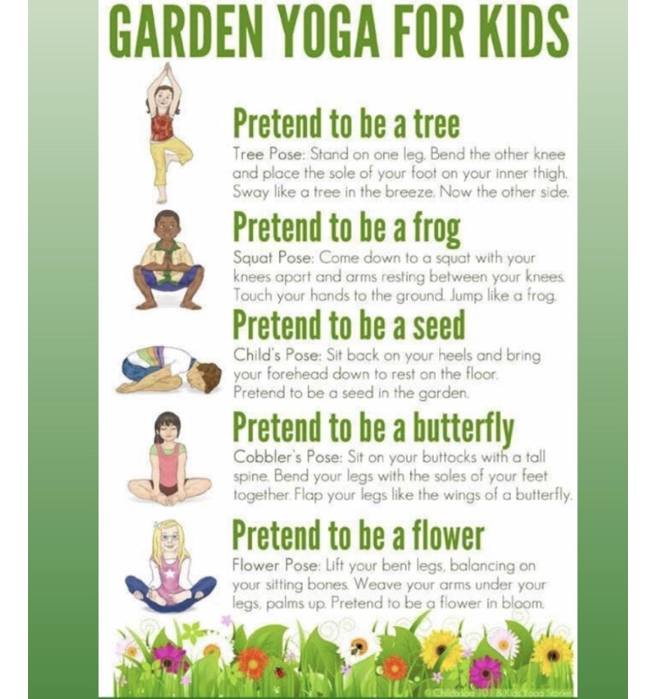
Music:
Explore: www. Classicsforkids.com
- go to games
- click on open instruments of the orchestra
- click explore to listen to the different instruments.
- You can read about each instrument while listening to a piece of music with that instrument
- pick your favourite instrument
- Draw an instrument
Perform song ‘Hush Little Baby’ https://rainbow.cjfallon.ie/#/units/senior/15 ( linked to Aistear)

Additional English:
www.studyladder.com ( email me if you want to set your child up on this and I will send you log in details. )

Additional Gaeilge:
Login to www.folensonline.ie
Use your email and go to teacher login using school roll number Prim20
Abair Liom B is the Senior Infants book. Go to resources and narrow down the search by clicking on Gníomhaíochtaí. Listen to the conversation ‘An Seomra Ranga’ and answer the questions. The next box is Póstaer. Click into this and complete the activites inside.

https://www.twinkl.ie/resource/roi-t-t-9087-draw-the-weather-activity-sheet

SPHE:

- https://www.youtube.com/user/CosmicKidsYoga

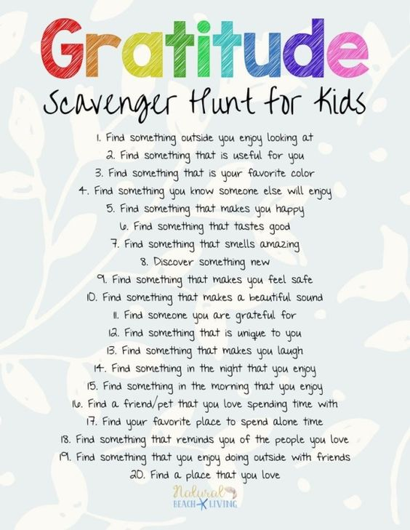
I cannot express enough that none of the above is compulsory. I know it is an extremely stressful time for everyone. Looking forward to seeing ye all soon.

My email: gnsseniorinfants@gmail.com

